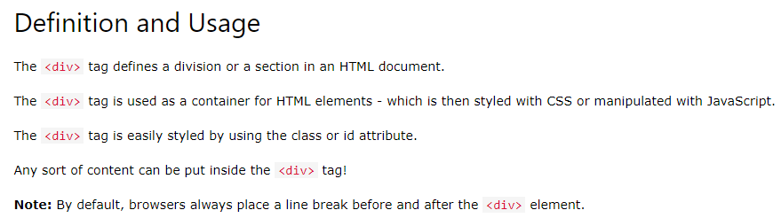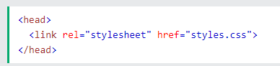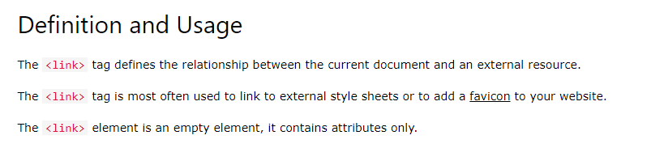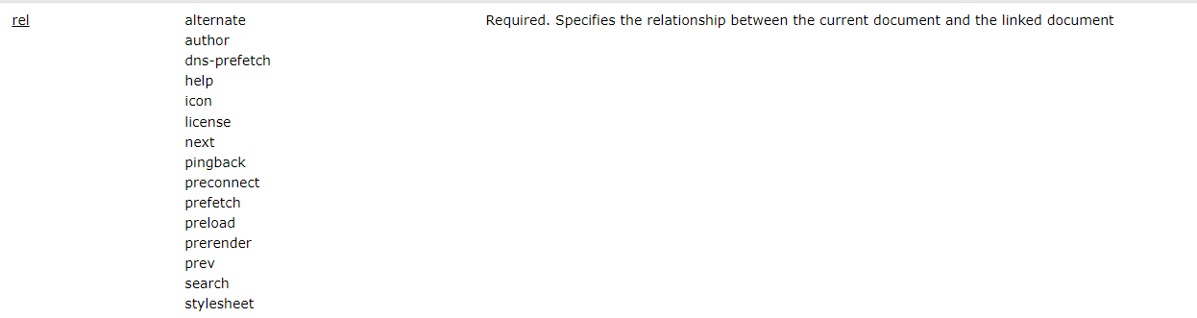

display: flex, is applied on parent element and aligns child elements side by side

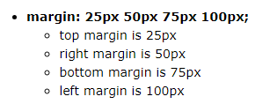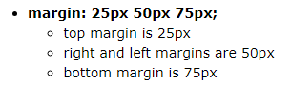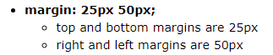

let data type in java script is use when data of the variable will change.

The global **setTimeout()** method sets a timer which executes a function or specified piece of code once the timer expires. Timer is in milli seconds. 1second=1000mili second.